PROJECT PROFILE
Project Title: Climate Change Adaptation Programme in Water and Agriculture in Anseba Region (Project No. 00078054)
Expected Outcome (SRF): Capacity Support provided to enhance food production at national and household level
Expected Outcome indicator: Increased food security through mainstreaming climate change policies and strategies
Expected Outputs:
- Food production and productivity increased through technology transfer
- Land productivity increased through water harvesting and management, diversification and intensification of production under irrigation and rain fed systems.
Coordinating Authority: Ministry of National Development
Reported by: Ghebremeskel Tewolde – Project Coordinator
The Programme Objective is to increase community resilience and adaptive capacity to climate change through an integrated water management and agricultural development approach in the sub-zobas of Hamelmalo and Habero, Anseba region, Eritrea. The programme will adopt a participatory approach working with vulnerable groups in particularly drought-prone areas of Anseba region, including small-scale farmers, agro-pasturalists and rural women

Programme Period: 2013-2016
Programme Componet: Climate Change Adaptation
Project Title: Climate Change adaptation Programme in Water & Agriculture in Anseba Region
Project Code: 0078054
Project Duration: 2013-2017

Background
The Habero and Hamelmalo are located in the Anseba region and bisects by the Anseba river. Large Part of these areas has been deforested and the rugged topography is exposed to severe soil erosion reducing the topsoil and making the forest and woodland regeneration difficult. The two sub regions have been identified as having vulnerable livelihood system, low agricultural productivity and ranked among the most top zobas affected by food insecurity due increased impact of climate change and rainfall variability.
The project is designed to enhance the availability of water for increased productivity and to develop the adaptive capacity of vulnerable communities by expanding small scale irrigation to increase agricultural production and to conserve soil and water through rangeland development.
Around 9000 household will be benefited from the intervention of the project. These people are victims of the climate variability as the y support their livelihood by growing crops and animal rearing. These sources of livelihoods will depend on soil and natural resources conservation and water sources to be developed.
Activities done in the project area
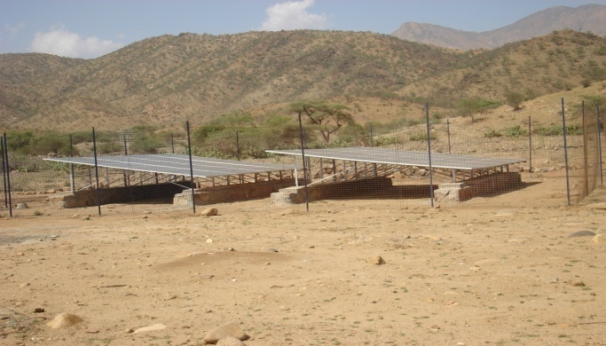
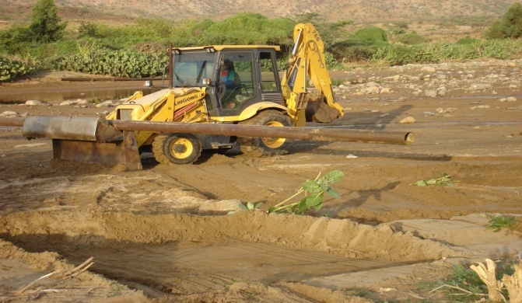
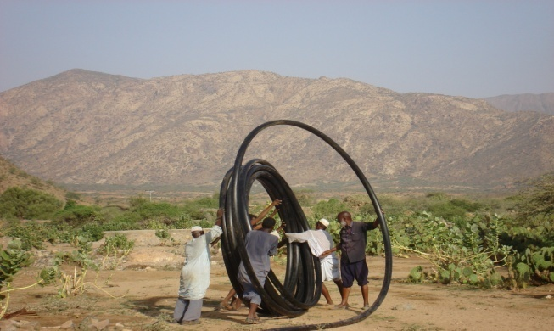
Irrigation Development: As part of promoting irrigation scheme in sub zoba Habero, a full set of solar irrigation is installed to irrigate 50 Ha. Of land which is situated in the downstream part of the existing two wells. Two solar pumps with a capacity of 7.5 Kw each and 48 Modules of 180Watt capacity with all accessories (switch board, inverter) are fixed to generate a power to channel water to the upper part of the farm. Moreover, 10 Rolls of HDPE pipe with Ø 90mm each roll 100M length a total of 1000M pipe, 50 pieces of Ø 3’’ GI pipe a total length of 300M, 10 rolls (100M) Ø 32mm which uses as conduit for installing cable 700M with 35M³ and 1000M 3.5mm is buried. In order to protect the solar arrays from any damage and human interference a 144 M² of area fenced with mesh wire. This irrigation system will have a great contribution in securing power for irrigating the farm; and minimize the farm expenses for purchasing fuel. Picture Shows installation of solar & pipes at sub zoba Habero

Construction of 300 M³ for irrigation development in Fiza is underway. After a design and BoQ is prepared, the document is distributed to different contractors; as a result it would be able to award to the bid to one of the legible bidders.
Nursery Development: To renovate the existing nursery which is located at Zeron in sub zoba Hamelmalo, nursery workers recruited. Currently the nursery site has a potential of propagating half a million of different types of seedlings. In order to render and produce many seedlings to the nearby communities, the nursery should be enforced in full scale. 13 workers have been recruited; moreover, various types of tools like water pumps, pipes, pick axle, shovel and ricks are purchased. the project also fund for all expenses which are spent to run and maintain the nursery.
Construction of Diversion structure: In Two site of sub zoba Habero (Fiza and Lemayte) construction of diversion structure undergone. So fur much of the works have been done. About 90% of the proposed activities for the construction of the diversion structure are completed. A diversion weir is complete. The dimension of the weir is 132M long; 5.7M total wall height (3.2M depth of foundation and 2.5M of wall height from the ground) and average
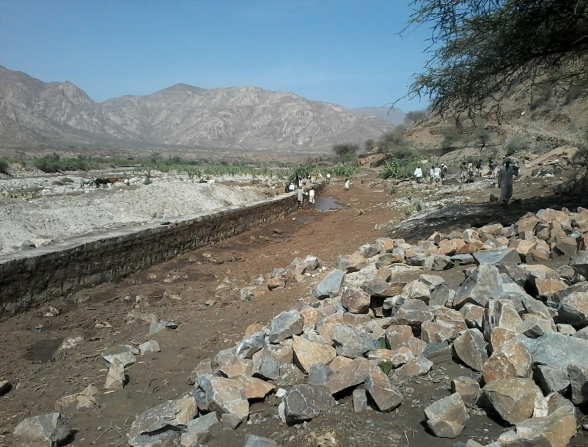
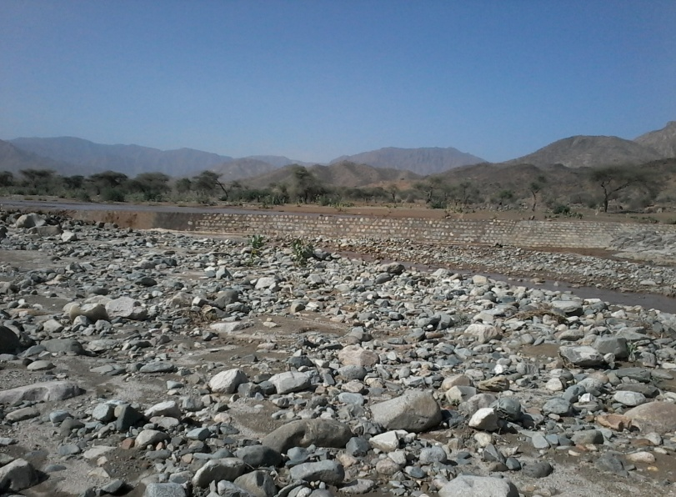
width of 3.15M. So fur 306 Meters of canal have constructed in two diversion area (136M lemayte and 170M Fiza). 8 diversion gates with a dimension of 2 M * 1.5 M each prepared and fixing of the gates and pointing of the structures is underway. For the past Nin months about 2,509M³of stones, 992 M³ and 28 M³ of gravel have been used for the construction of the structure. This diversion Structures serve to supply water for irrigating 124 Ha. 200 househol
Weir and Diversion structures in sub zoba Habero
get an access of water to boast up their agricultural production. 368 people are participating during the construction; and 8% of them are women.
Dam Construction: Two micro dam have been under construction. Both of the dams are constructed in sub zoba Hamelmalo.Gebesi dam which holds 120,000 M³ is completed. This dam has a potential of irrigating 10 Ha. 95% of the second dam at Wazntet village is executed. This dam mainly uses to provide an access of water for livestock and human’ and for the enriching the ground water. Around 130 people are engaging in the construction of dam at wazntet area.10% of them area women.
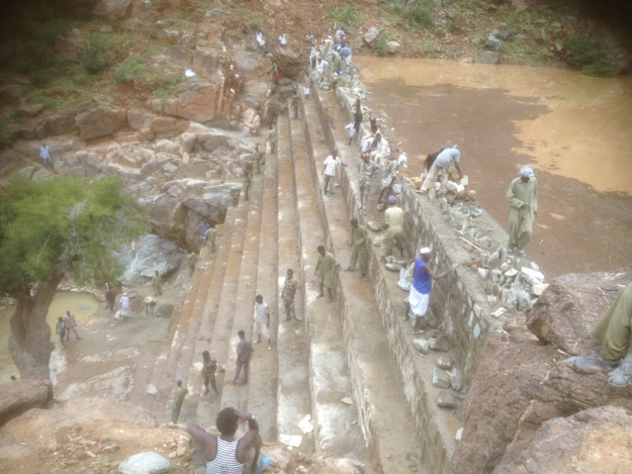
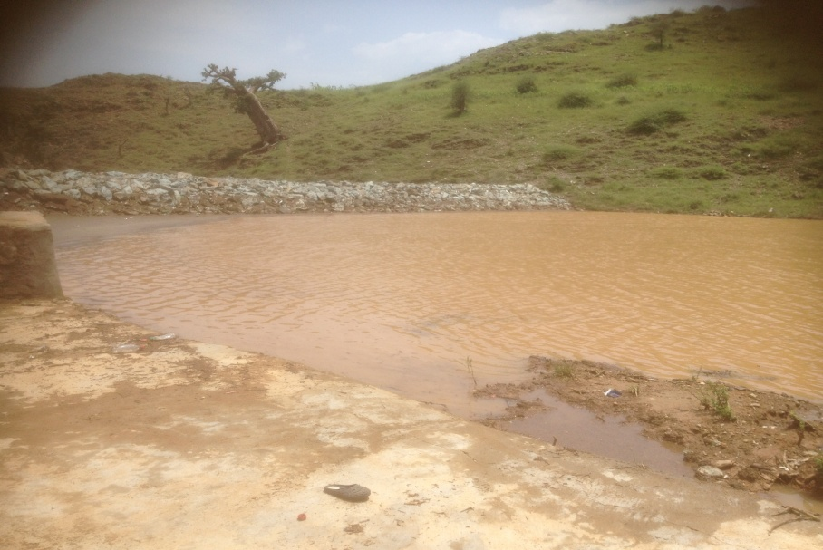
The finished dam at Gebesi and Wazntete
Introduction of Drought resistant, heat tolerant and early matured crops: a seed committee which comprises a professor from hamelmalo college of Agriculture, agronomist and head of crop promotion of ministry of Agriculture and climate adaptation project coordinator was formulate in order to make an assessment for the procurement of improved seed. After a detailed survey, the committee purchased 339.32 quintals of improved seeds. 134.97 quintal of pearl millet and 204.35 quintal of sorghum have already been distributed to sub zoba Hamelmalo and Habero. All the seeds procured from Gash Barka; a germination and purity test was conducted in the HAC Laboratory. From the analysis a good result was obtained which are 96% purity and 95% germination for sorghum and 90% purity and 92% germination for pearl millet. As a result it’s recommended there won’t be any crop failure to be happened if these seeds are planted.
Due to the subsequent drought facing in the sub zoba Hamelmalo and Habero, the farmers couldn’t keeps seeds. Therefore, in these sub zobas availability of improved seeds becomes critical for enhancing the production and productivity per unit area. The amount of seeds distribute, area covered and number of beneficiaries is as fallows
S.No | Sub Zoba | Pearl millet |  |  | Sorghum |  |  | Total |  | Total Beneficiaries
 |  | Quantity(Qtl) | Area  planted (Ha.) | Beneficiaries | Quantity(Qtl) | Area planted (Ha.) | Beneficiaries | Quantity(Qtl) | Area  planted (Ha.)
1 | Hamelmalo | 51.70 | 646 | 646 | 100.17 | 1001 | 1001 | 151.87 | 1647 | 1647
2 | Habero | 83.27 | 1040 | 1040 | 104.18 | 1042 | 1042 | 187.45 | 2082 | 2082
 | Total | 134.97 | 1686 | 1686 | 204.35 | 2043 | 2043 | 339.32 | 3729 | 3729
From improved seed distribution it’s expected the yield to increase by 15%-20%; ultimately, this supports the farmers to improve their livelihood. Besides the distribution, the ministry of Agriculture particularly crop development unit in collaboration with HAC are conducting trials to prove the adaptability of the new seeds released from the Hamelmalo college and make ready some seeds for the next year. To display the outcome and performance of the new crops a field day was conducted. 43 famers and experts were participated and witnessed the performance of the crop vis-à-vis the landrace in terms maturity, productivity and striga resistance. They expressed their commitment to propagate the seed in their area in wider level.
Baseline survey and EIA study: a team from HAC has been deployed to conduct baseline and EIA in the sub zoba of Hamelmalo and Habero. A contract agreement was signed with National board for higher education and ministry of land, water and environment. The study is underway in 8 representative kebabis of the sub zoba Hamelmalo and Habero.
The finding of the study was presented to all stakeholders in Keren. After a validation of the reports the study is finalized and submitted to all project partners. The feedback of the participants is very impressive and supportive to address the project objective to the communities. The report assessed each every component of the project, if the proposed outcome of the project would hit the goal of the project.
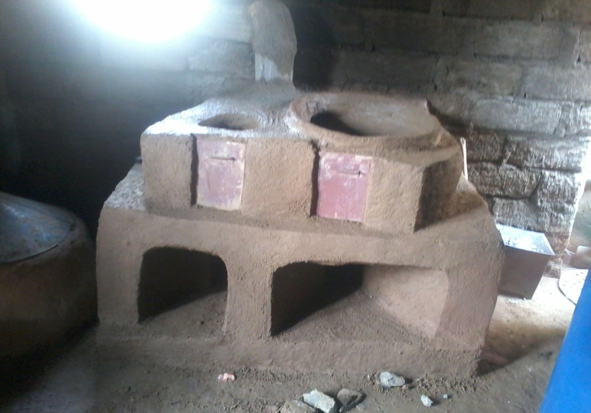
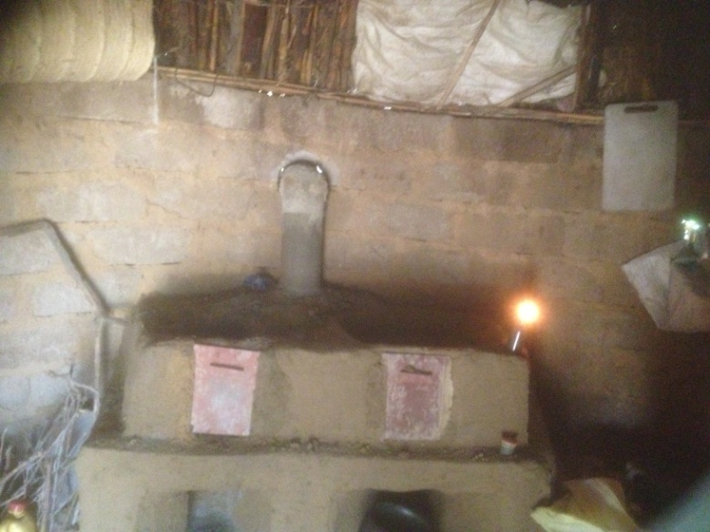
Introduction of improved stoves (Adhanet): Introduction of improved stoves in vulnerable sub zobas of Hamelmalo and Habero has an indisputable impact not only on mitigation deforestation and fuel wood deficiency but also improves the health status of the household. Based on this fact, the communities of these sub zobas have shown a great dedication to adopt the technology. As a result, 63 women were trained to provide training for the rest of the households. Each trained women will be responsible to train at least 5 nearby women. As model 79 stoves were made in these sub zobas. This accounts 20% of the intended construction. All the necessary materials for the construction of 400 stoves are provided and ready in each sub zoba. The construction work is undergone, and by the end of this year all the proposed stoves will have been finished.
Improved stove constructed by the trained women
Before an implementation of the construction of stoves, a committee is formulated and consultative meeting with trained women was conducted in their respective villages.
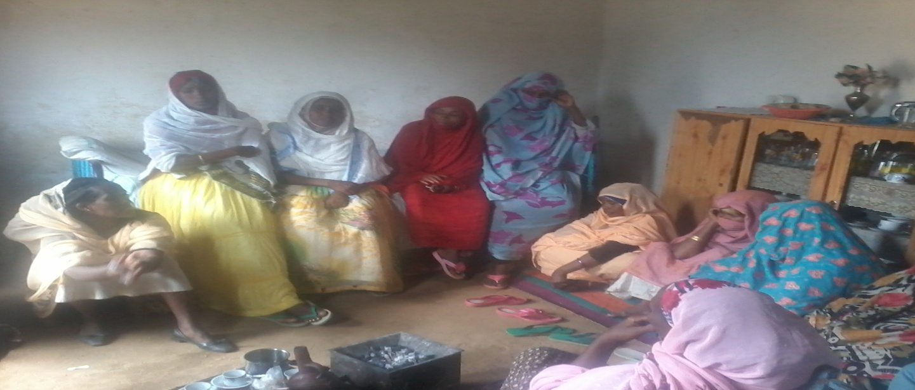Meeting of the home economic experts and trained women
Establishment of metrological station: In order to strengthen the prediction of climate variability in the region a full set of met station needs to be established. Two sites at sub zoba Hamelmalo college of Hamelmalo and at sub zoba Habero Aretay are identified in collaboration with meteorological experts from civil aviation, water resource department and ministry of Agriculture. All equipment for meteorological station is procured as per specification of the met. Experts. After the preparation of design for the fencing and meteorically house, the construction works is given to Governmental contract; and the construction is under gone in these two sub zobas. 90% of the work at HAC has been executed. Some activities like clearing of the site in sub zoba Habero is also started.

Financial Report for the year 2014
Activities | Actual Expenditure |  |  |  |  | Authorized
 | 1st quarter | 2nd quarter | 3rd quarter | 4TH quarter | Total | 1st quarter | 2nd quarter | 3rd quarter | 4TH quarter | Total
Irrigation Development | 0 | 3,521,700.00 | 0 | 5,000,000.00 | 8,521,700.00 | 0 | 3,500,000.00 | 1,500,000.00 | 5,000,000.00 | 10,000,000.00
Construction of small scale diversion | 3,948,075.50 | 3,193,193.00 | 834,519.02 | 170,000.00 | 8,145,787.52 | 3,798,379.50 | 1,854,653.00 | 1,000,000.00 | 170,000.00 | 6,823,032.50
Nursery Development | 333,460.00 | 18,202.40 | 16,427.00 | 200,000.00 | 568,089.40 | 333,460.00 | 200,000.00 | 80,000.00 | 200,000.00 | 813,460.00
Dam construction | 1,890,070.00 | 3,043,812.70 | 1,281,745.73 | 250,000.00 | 6,465,628.43 | 1,890,070.00 | 2,000,000.00 | 400,000.00 | 250,000.00 | 4,540,070.00
Construction of improved stoves | 0 | 0 | 640,520.00 | 0 | 640,520.00 | 0 | 495,000.00 | 500,000.00 | 0 | 995,000.00
Introduction of drought resistant crops | 0 | 1,097,222.00 | 47,000.00 | 0 | 1,144,222.00 | 0 | 1,823,099.00 | 100,000.00 | 0 | 1,923,099.00
Establishment of meteorological station | 0 | 0 | 2,460,843.96 | 895,437.00 | 3,356,280.96 | 0 | 0 | 800,000.00 | 895,437.00 | 1,695,437.00
Soil and water conservation works (terracing & check dams) | 0 | 0 | 0 | 0 | 0.00 | 0 | 1,000,000.00 | 1,000,000.00 | 0 | 2,000,000.00
Baseline survey | 0 | 150,000.00 | 100,000.00 | 0 | 250,000.00 | 150,000.00 | 150,000.00 | 100,000.00 | 0 | 400,000.00
Operating expenses | 100,303.20 | 148,110.40 | 298,431.89 | 200,000.00 | 746,845.49 | 99,488.00 | 150,000.00 | 200,000.00 | 200,000.00 | 649,488.00
Audit Report | 0 | 0 | 0 | 20,000.00 | 20,000.00 | 0 | 0 | 0 | 20,000.00 | 20,000.00
Total | 6,271,908.70 | 11,172,240.50 | 5,679,487.60 | 6,735,437.00 | 29,859,073.80 | 6,271,397.50 | 11,172,752.00 | 5,680,000.00 | 6,735,437.00 | 29,859,586.50

Summary of financial expenditure
S.No | Activities | Actual expenditure | Authorized Amount | Balance
1 | Irrigation Development | 8,521,700.00 | 10,000,000.00 | 1,478,300.00
2 | Construction of small scale diversion | 8,145,787.52 | 6,823,032.50 | (1,322,755.02)
3 | Nursery Development | 568,089.40 | 813,460.00 | 245,370.60
4 | Dam construction | 6,465,628.43 | 4,540,070.00 | (1,925,558.43)
5 | Construction of improved stoves | 640,520.00 | 995,000.00 | 354,480.00
6 | Introduction of drought resistant crops | 1,144,222.00 | 1,923,099.00 | 778,877.00
7 | Establishment of meteorological station | 3,356,280.96 | 1,695,437.00 | (1,660,843.96)
8 | Soil and water conservation works (terracing & check dams) | 0.00 | 2,000,000.00 | 2,000,000.00
9 | Baseline survey | 250,000.00 | 400,000.00 | 150,000.00
10 | Operating expenses | 746,845.49 | 649,488.00 | (97,357.49)
11 | Audit Report | 20,000.00 | 20,000.00 | -
 | Total | 29,859,073.80 | 29,859,586.50 | 512.70

